Materials Needed
- Particle Texture (https://drive.google.com/file/d/1l5ShxjRMn3b19P83qog1yLXTV9C2VWcr/view?usp=sharing)
- Interaction Script (https://drive.google.com/file/d/1iLaCiV0PbMsJVjW3w3ay1D59daExF6wk/view?usp=sharing)

Important Notes
- This method only works IF the water itself is a flat plane. Water with vertex displacement can still work with this method but do be aware that it could break the interactive immersion.
- The interactive particle itself has no shadow, thus making it look a little “fake” in some sense.
- Particle system is based on (https://www.patreon.com/posts/30490169)

Particle System Setup
- Create a new Particle System in your scene
- Tick the Prewarm option, Start Lifetime between 2 and 3, Start Speed to 0, Start Size between 6 and 8, Start Color to White, and Simulation Space to World
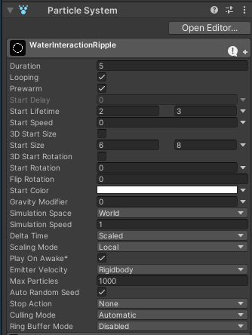
- Change the shape to Edge, with a very small Radius (0.1)
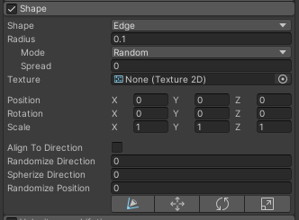

- Create a new Material set to Universal Render Pipeline/Particles/Unlit and add the above texture. Set the Surface Type to Transparent, Blending Mode to PreMultiply, and Color mode to Multiply
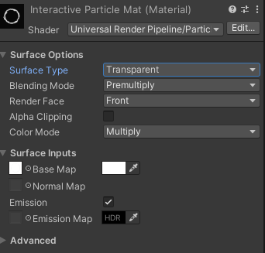
- In the Renderer section of the Particle System; Set Render Mode to Horizontal Billboard, Set Material to the new AlphaBlended Ripple Material, and set Sort Mode to Youngest in Front
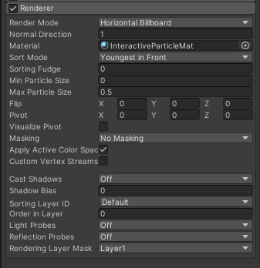

- Turn on Color over Lifetime and create a gradient of white that blends from and to 0 alpha
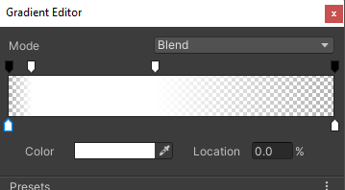
- Turn on Size over Lifetime and make a curve that starts growing quick and then gradually gets higher
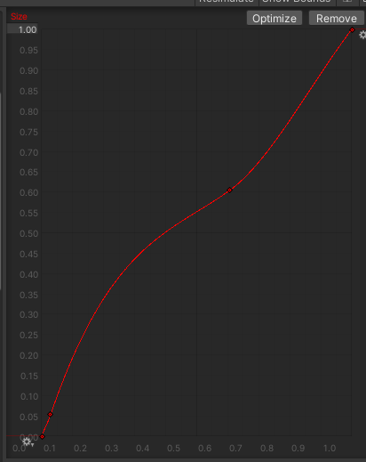
- Set the Rate over Time to between 1 and 2
Set the Rate over Distance to 4
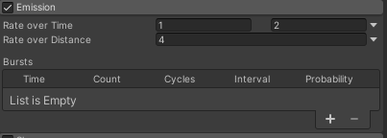
- Add the newly created Particle System as a child of the PlayerArmature
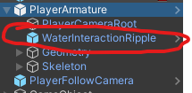

Water Collider Setup
- Create a Box Collider for the water mesh itself
- Tick the Is Trigger box

Script Setup
- Add the Water Interaction Script as a component of the PlayerArmature
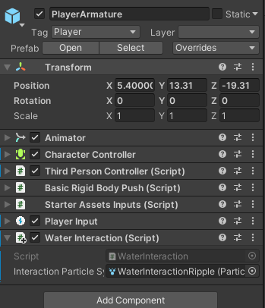
- Drag the Particle System into the Interaction Particle System parameter of the script

